Dietitians working in collaboration with Community Support Workers – A West Wimmera Health Service Project as part of the WHY Program

Main Messages
- The Home and Community Care (HACC) Program employs Community Care Workers (CCWs) to support frail aged people and people with disabilities with activities of daily living, including purchasing and preparing food. CCWs need to understand how nutrition relates to health to ensure their clients receive appropriate care, but receive no formal nutrition training. This project was developed with the hope that improving the nutrition knowledge of CCWs would have a positive impact on the nutrition-related health outcomes of their clients.

- A three-hour nutrition education session was developed for the CCWs in the Wimmera region. The session focused on delivering information on five key topics: The Australian Guide to Health Eating, important nutrients for healthy ageing, portion sizes, label reading and menu planning.
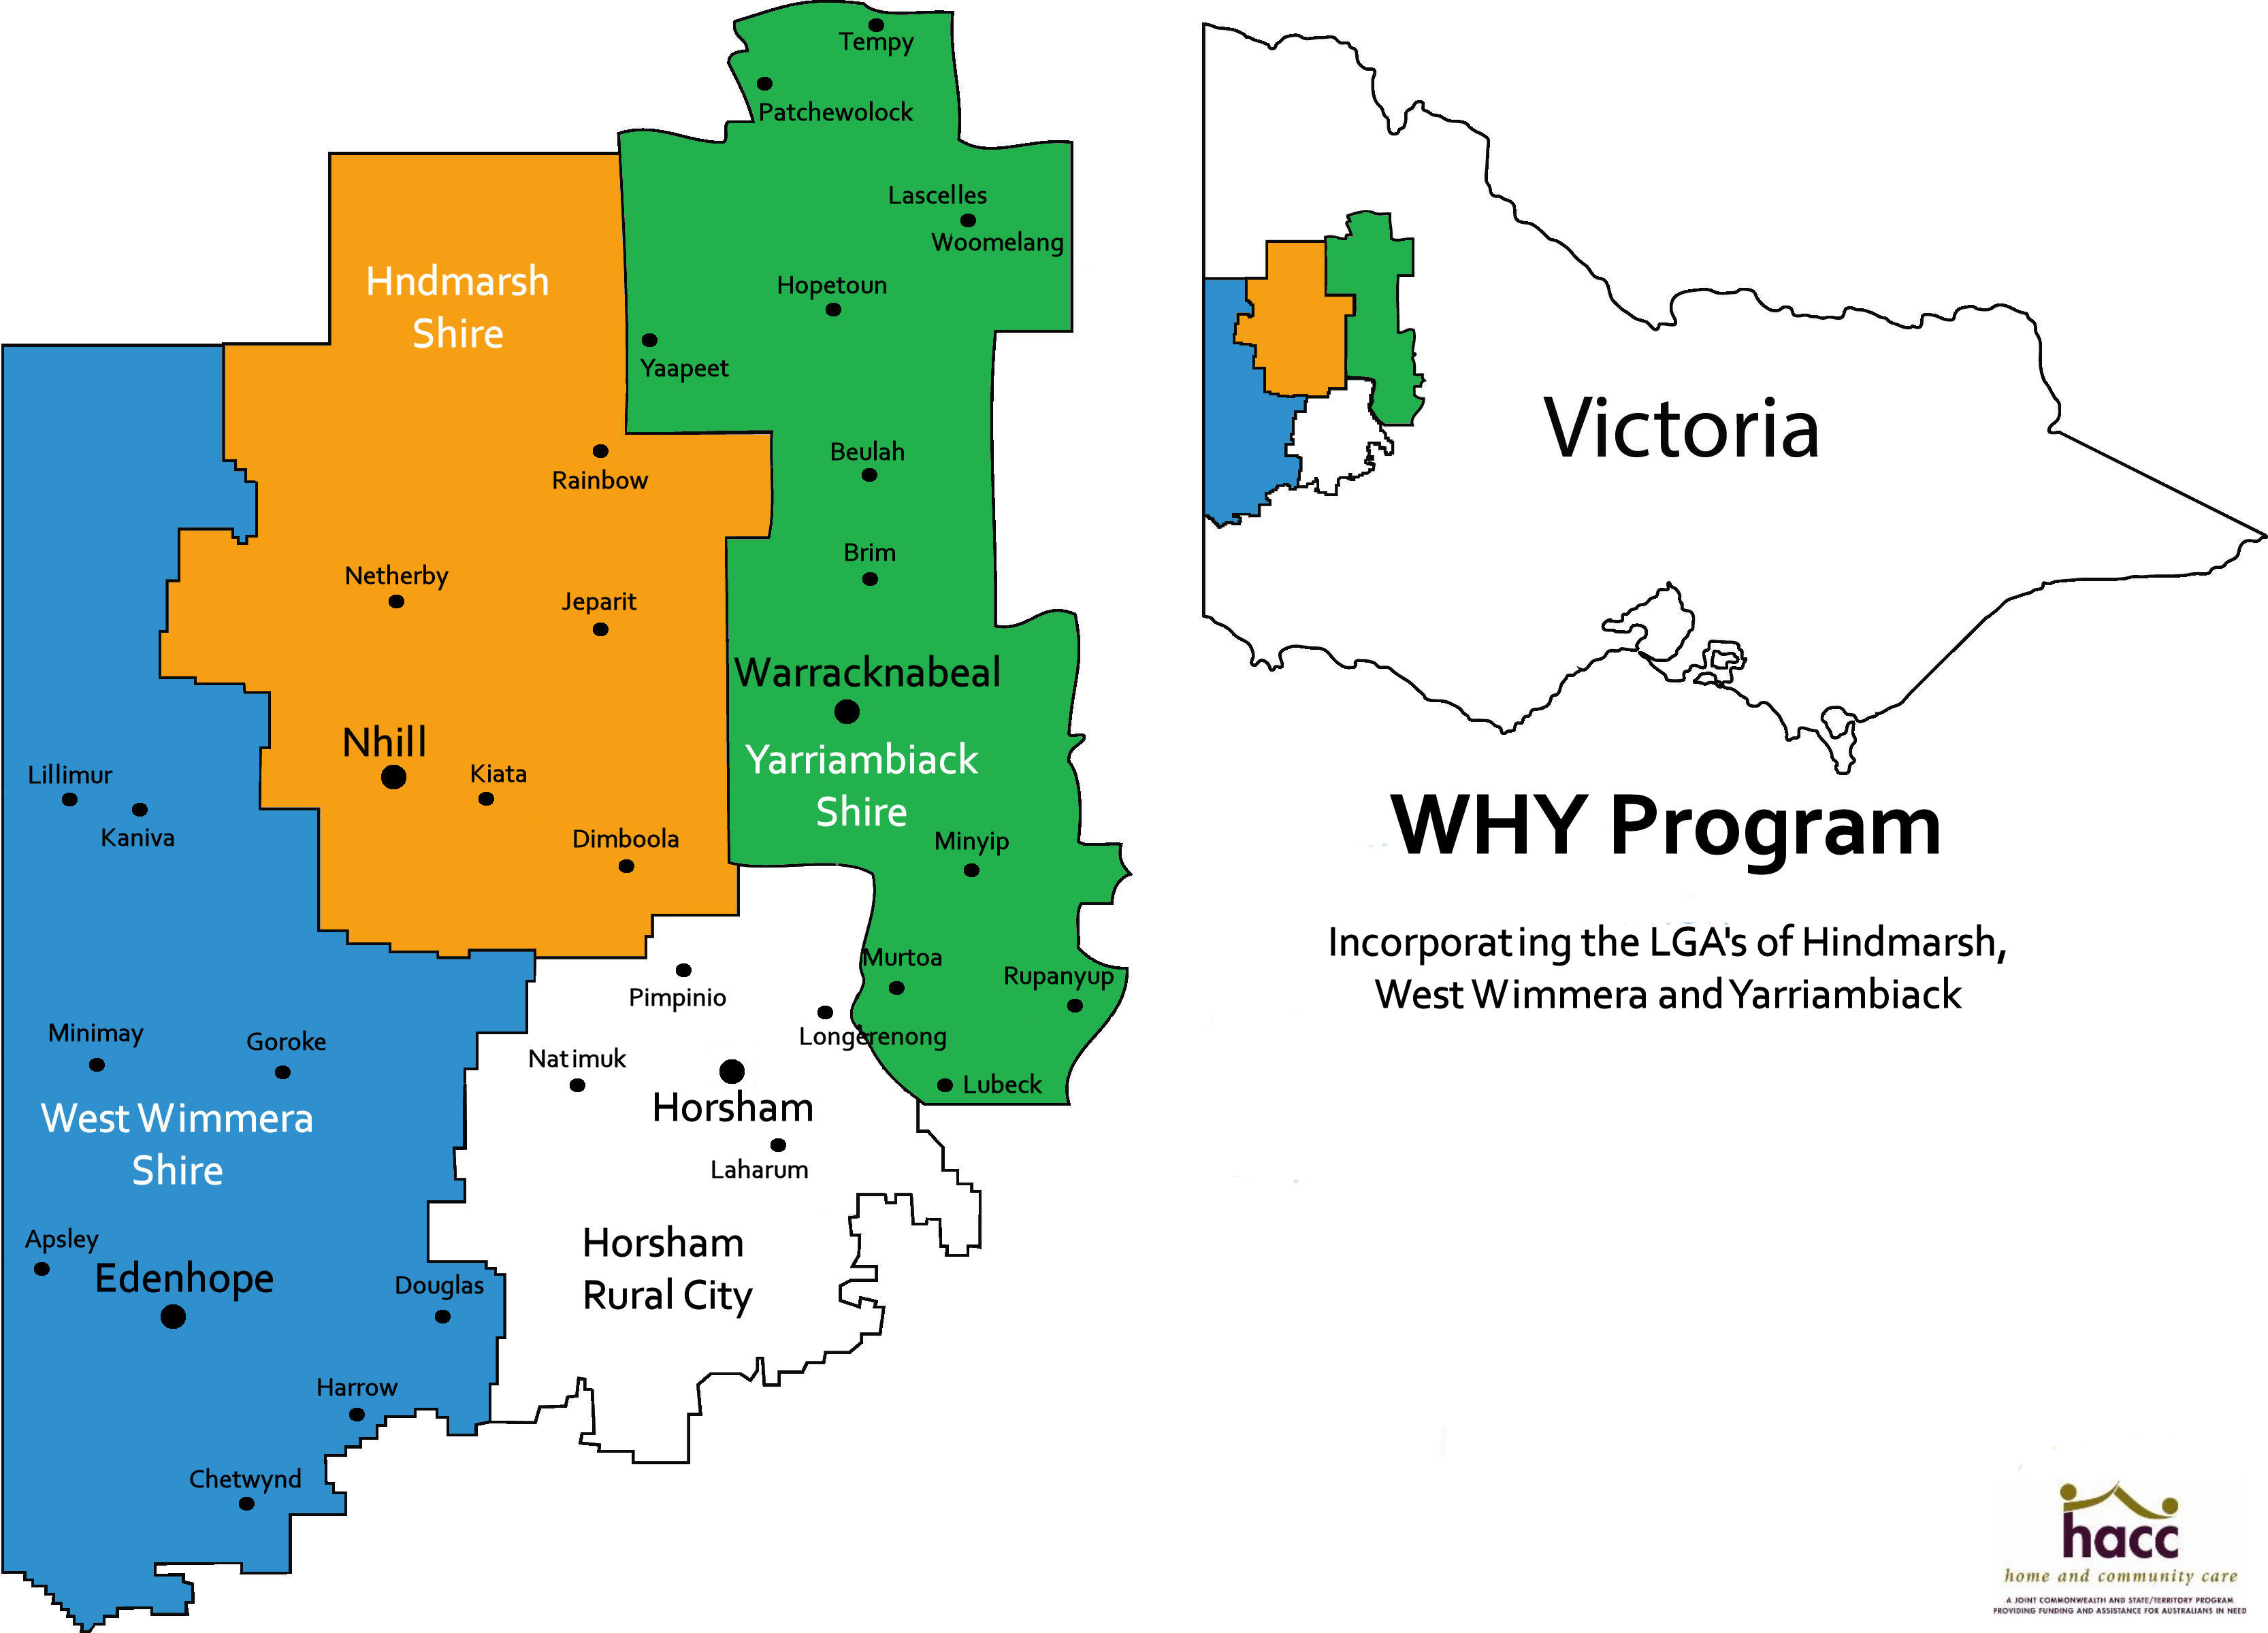

- Following the nutrition education sessions, CCWs scored 11% higher on the knowledge-based assessment survey and 4% higher on nutrition-related self-efficacy. It is unknown whether increasing knowledge will change nutrition-related behaviours and result in improved health outcomes for HACC clients.

- Ongoing nutrition education for CCWs should be implemented to ensure that CCWs develop the skills they need to support their clients’ dietary needs. Sessions should focus on developing the practical skills necessary to choose and prepare healthy foods. Additionally, tracking referrals from CCWs and the nutrition-related health outcomes of their clients would establish the efficacy of nutrition education programs and justify their ongoing funding, development and implementation.
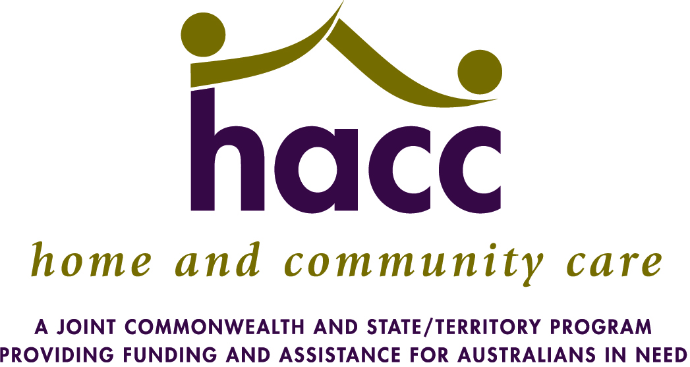

Executive Summary
Malnutrition risk is significantly higher among elderly and disabled individuals than in the general population (1, 2). Community Care Workers (CCWs) employed through the Home and Community Care (HACC) program provide support services to this population, including purchasing and preparing food. While CCWs are responsible for providing food for people at risk of malnutrition, they have no training in nutrition and are often ill-equipped to prepare healthy, appropriate foods for their clients.

The Dietitian at West Wimmera Health Service (WWHS) identified that some HACC clients were not meeting dietary recommendations, and felt that a nutrition education program for CCWs had the potential to improve client’s diet quality and consequently their overall health. Additionally, CCWs have not been making referrals to allied health, so the presentation addressed how to make referrals.

The project involved delivering education sessions to CCWs in the West Wimmera, Hindmarsh, and Yarriambiack shires. The sessions covered the Australian Guide to Healthy Eating, important nutrients for healthy aging, estimating portion sizes, reading food labels, and menu planning. The sessions were mandatory for CCW continuing education. Each topic included a lecture and an activity to encourage collaboration, hands-on application, and self-directed learning. A handout with key messages supplemented the presentation and included tips, resources, healthy recipes, and information about how to make referrals.

CCWs scored 62.3% on a pre-session test designed to evaluate basic nutrition knowledge. Following the sessions, scores improved by 11%, with the greatest improvement related to understanding how to read nutrition labels. CCWs rated the session 8.3/10 for usefulness. Label reading and estimating portion sizes were identified as the most helpful things learned. Participants commented that the presentation was informative, comprehensive, and helpful, and that they learned a lot.

An ongoing nutrition education program for CCWs is recommended, and should focus on developing practical skills that will impact food choices, such as label reading and healthy cooking techniques. Future research should track changes in the CCWs’ nutrition knowledge and food-related behaviours, and track nutrition-related health outcomes of HACC clients to determine whether the education program positively impacts HACC program users.

A short video presenting the main outcomes of the project can be viewed here: http://www.authorstream.com/Presentation/chantelleelson-2247092-educating-community-care-workers-nutrition-wimmera-region/

For further information on this project, or to obtain a copy of the full report, please contact the Dietetics Department at West Wimmera Health Service.

