Central Highlands and Grampians Pyrenees
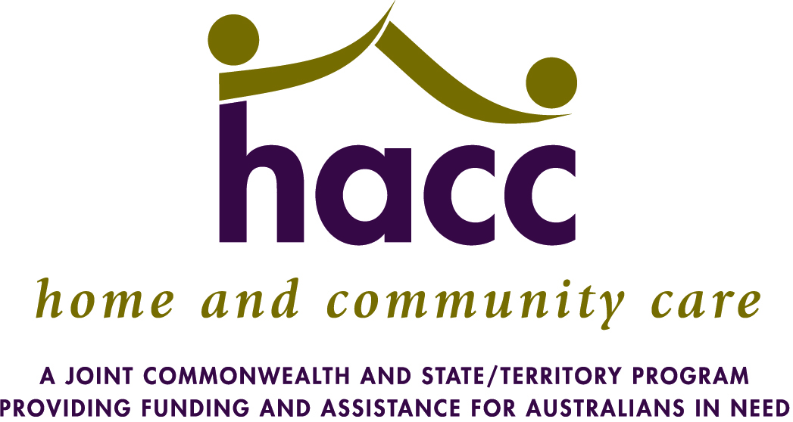
Living at Home Assessment Services
Client Assessment Check List
The role of this checklist is:
- To act as a record of the assessment process
- To capture the timeframes from referral receipt to assessment
- To acknowledge that not all information is collected or provided at the initial assessment – extra columns are to capture the ongoing nature of assessment
- At annual review a new checklist should be completed.
- NB This tool has been amended to reflect the changes in SCTT 2012

Client Name: Date of Birth: Record No:

New Client? Client review due to change? Annual Review?
LAHA Steps | Signature | Date | Signature | Date
Review Service Eligibility
Check HACC eligibility
Check financial status – record pension(Centrelink/DVA and Medicare numbers
Seek consumer consent to assessment
Determine with client who will be present at assessment
Confirm time and date with all intending to attend
Commence Grampians Region Service Provider Home Safety Checklist
Assessment Process
Explain (and provide service documents related to)
Overview of services
Confidentiality/privacy of information and how it will be used
Advocacy and client’s right for others to be present
Complaints system
Consumer rights and responsibilities
Undertake holistic assessment and capture/document information
contained within the SCTT forms below:
Consumer information (Same name – new items and format)
Living and caring arrangements (Accommodation and Safety)
Functional assessment summary (no change)
Need for assistance (with Activities of Daily Living)
Health behaviours (ASSIST)
Health conditions (Health and Chronic Conditions)
Psychosocial (Social and Emotional Wellbeing)
Family and social network (Care Relationship and Family and Social Network Profile)
Palliative care (if appropriate) (no change)
Complete Section Two of the Grampians Region Service Provider Home Safety Checklist
Consider and discuss other services of relevance to client such as:
Social support/ social connections
Informal support with family/friends
Allied health, ie OT, dietitian, balance, podiatrist, nursing
Complex health assessment ie ACAS, CACPS, Linkages, EACH, EACHD
Home support and maintenance

LAHA Steps | Signature | Date | Signature | Date
Client Consent to referrals, agreed care plan and information sharing
Discuss and clarify the clients goals and agreed action plans
Discuss with the client and/or carer if a Care Coordination plan or Service Specific plan is required – complete the agreed care plan
Client (or carer) signed the agreed care plan
Assessor signs the agreed care plan and goals
Document consumer consent to service delivery and referrals
Undertake referrals as agreed – refer using Connecting Care or RIMS using the following SCTT forms:

Consumer information
Consumer consent to sharing information (Consent to Share Information)
Summary and referral information
Living and caring arrangements (Accommodation and Safety)
Functional assessment summary
Any other relevant SCTT profiles
If referring to another LAHA service – attach copy of full SCTT/referral
Assessment report
Attach the Grampians Region Service Provider Home Safety Checklist to all referrals
Document in your records that your referral has been acknowledged, accepted, rejected
Send the Outcome of Referral/Assessment form to the referring body
Completing a Care Coordination Plan – are the client care requirements complex, there is more than 1 agency/provider involved and client is requesting/requiring assistance to manage their care?
Document client consent to participate in/allow a Care Meeting to occur
Advise client of which other services providers will attend
Ensure client understands that they are welcome to have an advocate
Organise Care Meeting – allocate Key Worker if appropriate
Document and distribute Care Coordination Plan
Client Support Information
Personal emergency plan document (fire, heatwave, flood)

Name of Assessor: Position:
Present at Assessment:
Signature of Assessor: Date of Assessment:
Date of Referral: Date of First Contact:

