Audit Tool for Completed Support (Care) Plans: NB For Multiple/Collated Support Plan reviews
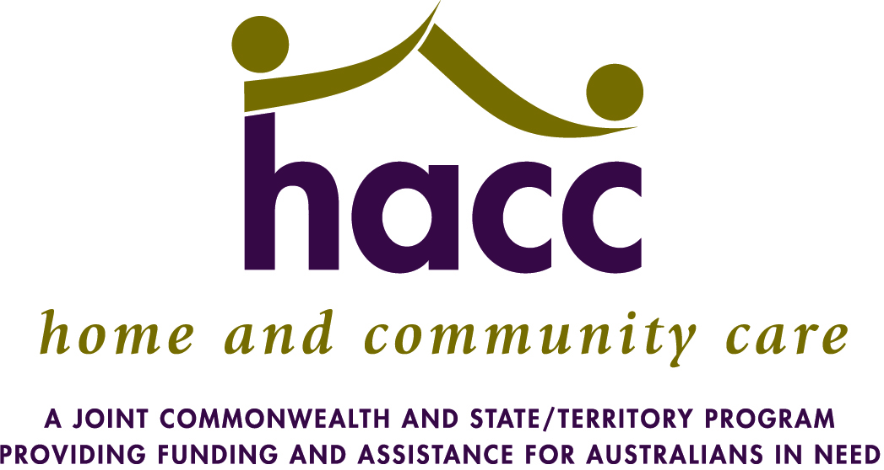
Developed by Kate Pascale and Associates, March 2013 – original is in EMR HACC Goal Directed Care Planning Toolkit.
Modified in February 2015 to manage multiple Support Plan audits for the Grampians Region HACC Program.
Audit Criteria | Rationale | Scale | Actual Rating Total for Collated Care Plan Reviews
- The client has a documented care plan | A care plan should be documented utilising the approved template/format that provides an overview of the way in which the service will support the client achieve their goals | 1 - Yes  0 - No
- If the client does not have a care plan, the rationale for not completing the care plan is clearly documented | It is not always appropriate to formally set goals and develop a care plan for a client, however the rationale for not completing the care plans should be documented as per organisational procedures | 1 – Yes  0 – No  0 – N/A
- The dates that the care plan was completed are recorded | Readers should be able to quickly identify when the care plan was completed | 1 – Yes  0 - No
- The people involved in the development of the care plans are recorded | Person centred care highlights the importance of actively engaging the client and other relevant people (including carers, friends, family and other service providers) in the development and review of the care plan. The names of the people involved in care planning should be clearly documented (including roles of and organisation where relevant) | 1 - Yes  0 - No
- The writing in the care plan is legible | In order to be useable, a care plan needs to be easily able to be read | 1 - Yes  0 - No
- The language used in the care plan is appropriate to the client | The care plan should be written in language that is appropriate to the client, without the use of complex terminology or acronyms | 1 - Yes  0 – No
- The care plans provide an overview of the current context/current situation | The care plan should include a brief summary of the current situation, including the key issues that the client hopes to address through their care plan. This should provide adequate detail to enable the reader to understand how the subsequent goals fit into the clients overall life of context. The current context may include key points around the person’s priorities, capacities, values, support, issues and concerns | 2 – Always  1 – Sometimes  0 - Never
- The goals set clearly demonstrate what the client hopes to achieve | The goals should identify what the client hopes to achieve (in the short or long term). The goals may include hopes within and beyond the scope of services provided by your organisation | 2 – Always  1 – Sometimes  0 - Never
- Actions are recorded for each goal and clearly outline the key steps that need to be completed in order to achieve the goals | The documented action/s should pro9vide an overview of how staff will work with the client and other relevant people (including carers, family and other service providers) to support the achievement of each goal | 2 – Always  1 – Sometimes  0 - Never

Audit Criteria | Rationale | Scale | Actual Rating Total for Collated Care Plan Reviews Actual Score
- There are appropriate timeframes recorded for when each action will be completed | Specific timeframes should be articulated for each action, and reflect the client’s needs and priorities. This enables a care plan to be easily reviewed and helps to set out expectations for each party involved in the care planning process.  For some actions (e.g. sending referral), it is relevant to define a specific date for completion. For other actions (e/g/ daughter to provide transport until volunteer driver in place) it may be more appropriate to record a timeframe (ie 4-6 weeks) | 2 – Always  1 – Sometimes  0 - Never
- The person/people responsible for implementing each action are documented | In order to demonstrate clear accountability, a specific person should be assigned responsible for each action. In order to support a collaborative approach. It is I important to document the actions to be completed by staff, the client, carers and other relevant team members. | 2 – Always  1 – Sometimes  0 - Never
- There is a clear link between the actions and goals that are documented | Based on the care plan alone, readers should understand how each action relates to achieving the relevant goal/s | 2 – Always  1 – Sometimes  0 - Never
- There is evidence that, where appropriate, staff have engaged staff/other service providers to support the client achieve their goals | A person centred approach requires staff to think beyond d the scope of their service and support clients to address their goals in a holistic way. The care plan should reflect that, where appropriate, the client has been supported to access other relevant services to achieve their goals (e.g. via communication with and/or referrals made to other team members/organisation | 2 – Always  1 – Sometimes  0 – Never  0 – N/A
- There is evidence that the care plan is individualised and client centred | In order to be person centred, the goals set should reflect the individual needs and wishes of the client and be clearly linked to the client’s current situation/context. Goals and actions that are generic or reflect the services needs are not appropriate to be documented on a care plan | 2 – Always  1 – Sometimes  0 - Never
- A date or timeframe has been documented for when the whole care plan needs to be reviewed | In order to remain relevant, care plans need to be regularly reviewed. The time frame set for review will depend on the type of goals set and the timeframes for the achievement of these goals | 1 - Yes  0 - No
- Client acknowledgement | The client should sign the care plan, acknowledging that they have been actively involved in the development of the care plan and that they are happy with the information and actions included NB Documentation of verbal acknowledgement is also appropriate | 1 - Yes  0 - No
- There is evidence that a copy of the care plan was provided or offered to the client | In order for a care plan to be acted on by the client , they need written documentation as a record of the process | 1 - Yes  0 - No

Audit Criteria | Rationale | Scale | Actual Rating Total for Collated Care Plan Reviews
- There is evidence that, where appropriate, the care plan has been shared with relevant people | Communication of key information and the care plan is fundamental to interagency involvement and to delivering coordinated care. Given client consent, care plans should be shared with people involved in the delivery of care (including carers, family, staff and other services providers) | 2 – Always  1 – Sometimes  0 – Never  2 – N/A
Care Plan Development Total:

Additional Criteria for Care Plans that have undergone one or more reviews
Audit Criteria | Rationale | Scale | Actual Rating Total for Collated Care Plan Reviews
- The date that the care plan was reviewed is recorded | Readers should be able to quickly identify the date/s when the care plan was reviewed. If multiple reviews have been completed, all dates should be clearly documented. | 2 – Always  1 – Sometimes  0 - Never
- The people involved in each review of the care plan are recorded | The names of the people involved in care planning should be clearly documented (including roles and organisations where relevant). This may include people who have been consulted/provided feedback that informs the review and revision of the care plan (including carers, friends, family and other service providers) | 2 – Always  1 – Sometimes  0 - Never
- The client’s current context/current situation is updated to reflect the changing circumstances at each review | A very brief summary of the client’s current situation should be included in each review, highlighting changes in function, needs, priorities etc | 2 – Always  1 – Sometimes  0 - Never
- Actions have been completed in accordance with the timeframes set | This provides evidence that the care plan has been utilised | 2 – Always  1 – Sometimes  0 - Never
- The impact of completed action is documented in relation to goal achievement/outcomes | The completion of actions need to be linked back to whether this has supported the client achieve their desired outcomes (ie what they wanted to achieve by working with your service) | 2 – Always  1 – Sometimes  0 - Never
- Outstanding issues/next steps are noted | Outstanding issues need to be noted, demonstrating the rationale for revisions to the care plan (ie why actions are abandoned or modified and/or where alternative strategies are required to effectively support the client achieve their goals). Next steps are documented accordingly | 2 – Always  1 – Sometimes  - – Never
Audit Criteria | Rationale | Scale | Actual Rating Total for Collated Care Plan Reviews
- Where goals are inactive or no longer relevant, the reasons why are clearly documented | Goals may become irrelevant or inactive and the reasons why need to be clearly documented to assist with future care planning | 2 – Always  1 – Sometimes  0 – Never  2 – N/A
- Client acknowledgement | Revisions conducted as a result of a care plan review should be signed off by the client. NB Documentation of verbal acknowledgement is also appropriate | 1 - Yes  0 - No
- There is evidence that a copy of the revised care plan was provided or offered to the client after each review | Clients should be offered a copy of the care plan each time it is formally reviewed/revised | 2 – Always  1 – Sometimes  0 - Never
- There is evidence that, where appropriate, the care plan has been shared with relevant people | Communication of key information and the care plan is fundamental to interagency involvement and to delivering coordinated care. Given client consent, care plans should be shared with people involved in the delivery of care (including carer, family, staff and other service providers | 2 – Always  1 – Sometimes  0 – Never  2 – N/A
Care Plan Review Total Q19 to 28):

Total for Development and Review (Add Development and Review Totals):

