West Wimmera Shire, Hindmarsh Shire

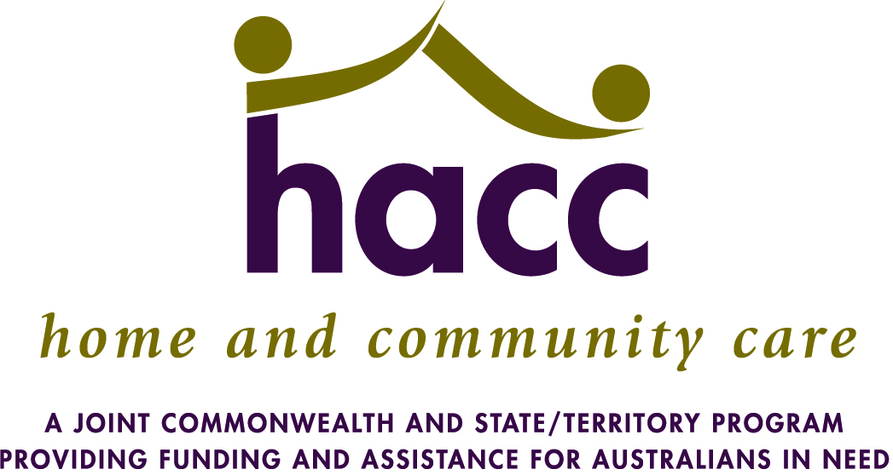
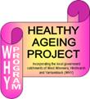
And Yarriambiack Shire
Healthy Ageing Project
Thank you for participating in the Living Well…..Ageing Better event – what follows is a list of healthy ageing and social activities that may already be available in your local community. If they are not available and there is sufficient interest from a number of people we will work with you to look at the possibility of developing this activity or something similar.
Please tick the type of activity group that would most interest you……….
Social walking group

Self education and further learning opportunities in special interest areas (eg. Neighbourhood House, Learning Centre, University of the Third Age)

Exercise group – for fun and fitness

Tai Chi

Better Balance exercise - falls prevention group

Gardening group or community garden

Reading discussion group

Golf or bowls for the almost young

Singing group

Healthy eating and cooking group

Fishing or social outings group

Dancing group

Movie group

Your suggestions for activities that are both fun and healthy: ……………………………………………….
………………………………………………………………………………………………………………….……………………………
……………………………………………………………………………………………………………………………………………….
If any of these groups interest you or you have suggestions for other healthy ageing activities please add your comments and we will make contact with you to explore your suggestions/interests.
Name: ……………………………………………………….. Phone Number: …………………………………………

Or Contact our Healthy Ageing Project Officer, Wayne John at West Wimmera Health Service – wayne.john@wwhs.net.au

