Healthy Ageing Community Talks
⃝ | Introduction to Healthy Ageing  What is healthy ageing and how can it be achieved. Participants learn how to develop their own healthy ageing plan using a provided planning tool.  ~20-30 mins
⃝ | Healthy Ageing and Type 2 Diabetes  Type 2 diabetes is the fastest growing chronic disease and a significant challenge to healthy ageing. How do you achieve healthy ageing when you have type 2 diabetes? Participants learn how to prevent or better self-manage type 2 diabetes and develop their own healthy ageing plan.  ~30 mins
⃝ | Stories of Ageing Well - Healthy Ageing Case Studies  Hear the inspiring stories of some real life older people and how they have been able to change their lives to improve their health and wellbeing.  ~20-30 mins
⃝ | Science and secrets on How to Achieve Healthy Ageing  Learn the ‘secrets’ of healthy ageing from the wisdom of the elders as well as the evidence from science on what enables people to add years to their life and life to their years.  ~20-30 mins
⃝ | Physical Activity and Healthy Ageing  Physical activity is vital to healthy ageing and to help prevent chronic disease. What is the role of muscles to promote better health and wellbeing and how you use your muscles to create healthy ageing.  ~20-30 mins
⃝ | Eat Yourself Healthy - Nutrition and Healthy Ageing  There strong scientific and clinical interest in the role of nutrition to affect the biological processes of ageing or to affect the physiology that promotes healthy ageing. What does nutrition science tell us are some practical ways to optimise nutrition to promote healthy ageing?  ~20-30 mins
⃝ | Healthy Muscles and How to Prevent Loss of Strength  Under development
⃝ | Healthy Bones and How to Prevent Osteoporosis  Healthy bones are integral to healthy ageing but as bone mass declines after age 30 how can older people have healthy bones? The age-related loss of bone mass can cause the bone weakness disease osteoporosis that affects many older people and can result in fragility fractures and associated mobility, strength and disability problems. A few simple lifestyle changes discussed in this session can keep bones healthy and prevent osteoporosis.  ~30 mins
⃝ | Man2Man – Ageing and Men’s Health  Let’s talk frankly about important men’s health issues and real solutions men can action to reduce risk of chronic diseases like prostate cancer and to improve their stamina, strength, health and wellbeing toward ageing well.  ~30 mins

To book a talk tick the one required, complete the details below and return to:
Wayne John
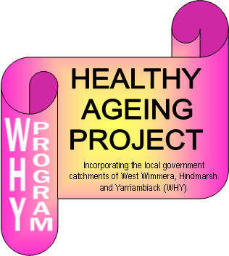
Healthy Ageing Project
Tel: (03) 5391 4385
Fax: (03) 5391 4228
Email: wayne.john@wwhs.net.au

Booking details:
Organisation:
Venue:
Contact person:
Phone:
Email:
Requested dates and times:

Comments:

The healthy ageing project offers community talks as a free service to community groups and service clubs to promote the health and wellbeing of older persons within our communities.
Updated 3 July 2014

