Healthy Ageing Education Workshops
Topics currently available:
⃝ | Introduction to Healthy Ageing  Healthy ageing is explained together with some steps older people can take toward improving health and wellbeing. Participants learn to develop their own healthy ageing plan using a planning tool that is provided.  80 mins
⃝ | Stories of Ageing Well - Healthy Ageing Case Studies  Hear the real life stories of a number of older people and how they have been able to change their lives to improve their health and wellbeing.  40 mins
⃝ | Science and Secrets on How to Achieve Healthy Ageing  Learn the ‘secrets’ of healthy ageing from the wisdom of the elders as well as the evidence from science as we explore the factors that enable people to add years to their life and life to their years. Hear about the 3 ‘hot spots’ in the world where National Geographic found populations that live longer, healthier and happier lives.  80 mins
⃝ | Physical Activity and Healthy Ageing  Physical activity is vital to healthy ageing and to help prevent chronic disease. What is the role of muscles to promote better health and wellbeing and how can you use your muscles to create healthy ageing?  60 mins
⃝ | Eat Yourself Healthy - Nutrition and Healthy Ageing  There is growing scientific and clinical interest for the role of nutrition to affect the biological processes of ageing or to affect the physiology that promotes healthy ageing. What does nutrition science tell us are some practical ways to optimise nutrition to promote healthy ageing?  60 mins
⃝ | Healthy Muscles and How to Prevent Loss of Strength  Module under development
⃝ | Healthy Bones and How to Prevent Osteoporosis*  Having healthy bones is integral to healthy ageing but as bone mass declines after age 30 how can older people have healthy bones? The age-related loss of bone mass can cause the bone weakness disease osteoporosis that affects significant numbers of older people and can result in fragility fractures and associated mobility, strength and disability problems. However, a few simple lifestyle changes discussed in this session can help keep bones healthy and prevent osteoporosis.  80 mins
⃝ | Stay on Your Feet and How do You Prevent Falls*  Falls are a main injury risk for older people and can cause permanent disability. Preventing falls is one of the important ‘must have’ components for healthy ageing to help maintain independence as people get older. In this topic we explore what causes falls and practical ways to prevent falls. Hear about the 93 year old man who has not had a fall since he started balance training enabling him to continue to live on his own at home. An interactive session that includes practical balance training exercises.  90 mins

To book tick the workshop(s) required, complete the details below and return to:
Wayne John
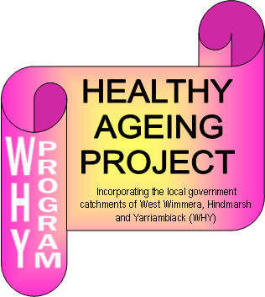
Healthy Ageing Project
Tel: (03) 5391 4385
Fax: (03) 5391 4228
Email: wayne.john@wwhs.net.au

Booking details:
Organisation:
Contact person:
Phone:
Email:
Requested dates and times:

Venue:
Comments:

*The sessions ‘Healthy Bones and How to Prevent Osteoporosis’ and ‘Stay on Your Feet and How to Prevent Falls’ are best booked together as a series.
These education sessions are a free service to health professionals, organisations, community groups and service clubs to promote the health and wellbeing of older persons.
Updated 3 July 2014

