Grampians Region HACC Program
Continence Care in the Community
Bladder and Bowel Screening Tool

Be aware at all times that incontinence is not a ‘natural part of ageing’ and it is not a disease, it is something that affects all ages.
At all times be supportive of clients who express concern about their bowel or bladder – be warm and understanding – it is not an easy thing for a client to raise a concern.
If you feel a concern has been identified it is your role to report this to your supervisor so that the client can be offered some assistance. This is a simple checklist that you and the client can fill out together if the client is agreeable and wants to talk about it. Just tick the relevant boxes:
Bladder Management
Do you sometimes feel you have not completely emptied your bladder?
If you feel a concern has been identified it is your role to report this to your supervisor so that the client can be offered some assistance. This is a simple checklist that you can use to report your concerns:

Do you have to rush to the toilet?
you feel a concern has been identified it is your role to report this to your supervisor so that the client can be offered some assistance. This is a simple checklist that you can use to report your concerns:

Are you frequently nervous because you think you might lose control of your bladder?
you feel a concern has been identified it is your role to report this to your supervisor so that the client can be offered some assistance. This is a simple checklist that you can use to report your concerns:

Do you wake twice or more during the night to go to the toilet?
you feel a concern has been identified it is your role to report this to your supervisor so that the client can be offered some assistance. This is a simple checklist that you can use to report your concerns:

Do you leak before you get to the toilet?
you feel a concern has been identified it is your role to report this to your supervisor so that the client can be offered some assistance. This is a simple checklist that you can use to report your concerns:

Do you plan your daily routine around where the nearest toilet is?
you feel a concern has been identified it is your role to report this to your supervisor so that the client can be offered some assistance. This is a simple checklist that you can use to report your concerns:

you feel a concern has been identified it is your role to report this to your supervisor so that the client can be offered some assistance. This is a simple checklist that you can use to report your concerns:

Do you leak when you laugh, sneeze, exercise or lift heavy things?
Bowel Management
Do you experience pain when you are having a bowel movement?
you feel a concern has been identified it is your role to report this to your supervisor so that the client can be offered some assistance. This is a simple checklist that you can use to report your concerns:

Do you pass wind unexpectedly or without being able to control/stop it?
you feel a concern has been identified it is your role to report this to your supervisor so that the client can be offered some assistance. This is a simple checklist that you can use to report your concerns:

Do you use your bowels less than three times per week?
you feel a concern has been identified it is your role to report this to your supervisor so that the client can be offered some assistance. This is a simple checklist that you can use to report your concerns:

What does your faeces look like? Have a look at the Bristol faeces chart on the back of this page and write what Type it most looks like…………
you feel a concern has been identified it is your role to report this to your supervisor so that the client can be offered some assistance. This is a simple checklist that you can use to report your concerns:

Do you ever find blood coming from your bowels or is in your faeces?
you feel a concern has been identified it is your role to report this to your supervisor so that the client can be offered some assistance. This is a simple checklist that you can use to report your concerns:

Do you have accidents where you can’t make it to the toilet?
you feel a concern has been identified it is your role to report this to your supervisor so that the client can be offered some assistance. This is a simple checklist that you can use to report your concerns:

Are you anxious about your bowels for any reason?
you feel a concern has been identified it is your role to report this to your supervisor so that the client can be offered some assistance. This is a simple checklist that you can use to report your concerns:

If the client answers ‘yes’ to any of these questions then they may have a bladder or bowel management problem. Please return this completed tool to your supervisor.
Comments:

Client Name: Worker Name: Date:
Please return this tool to your supervisor when you report your concerns.
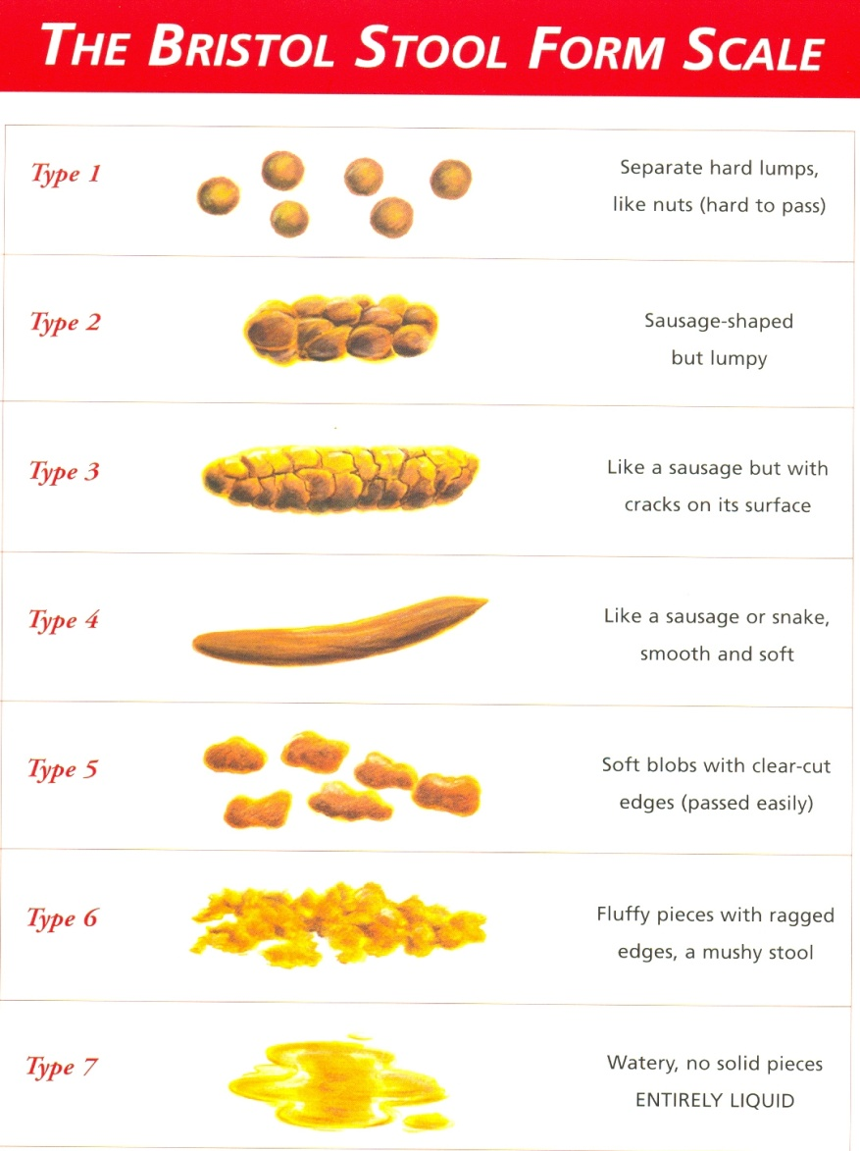
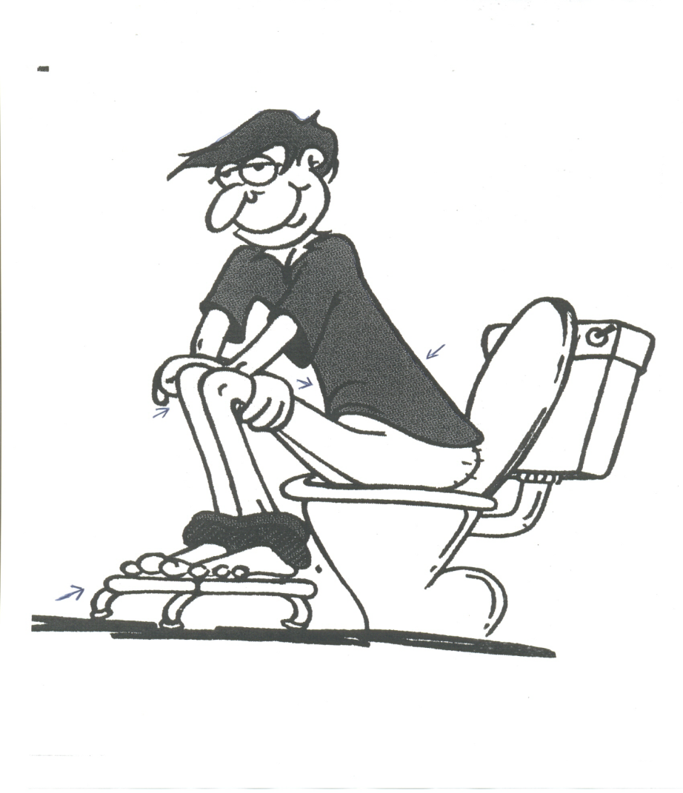Correct Sitting Posture on the Toilet

Bladder Self Management Questionnaire, Continence Management Strategy: ww.continence.health.gov.au

