January 2019

Wimmera Cancer Telehealthcare
Toolkit

This Toolkit provides a blueprint for a rural health service looking to implement Telehealth for cancer patients.
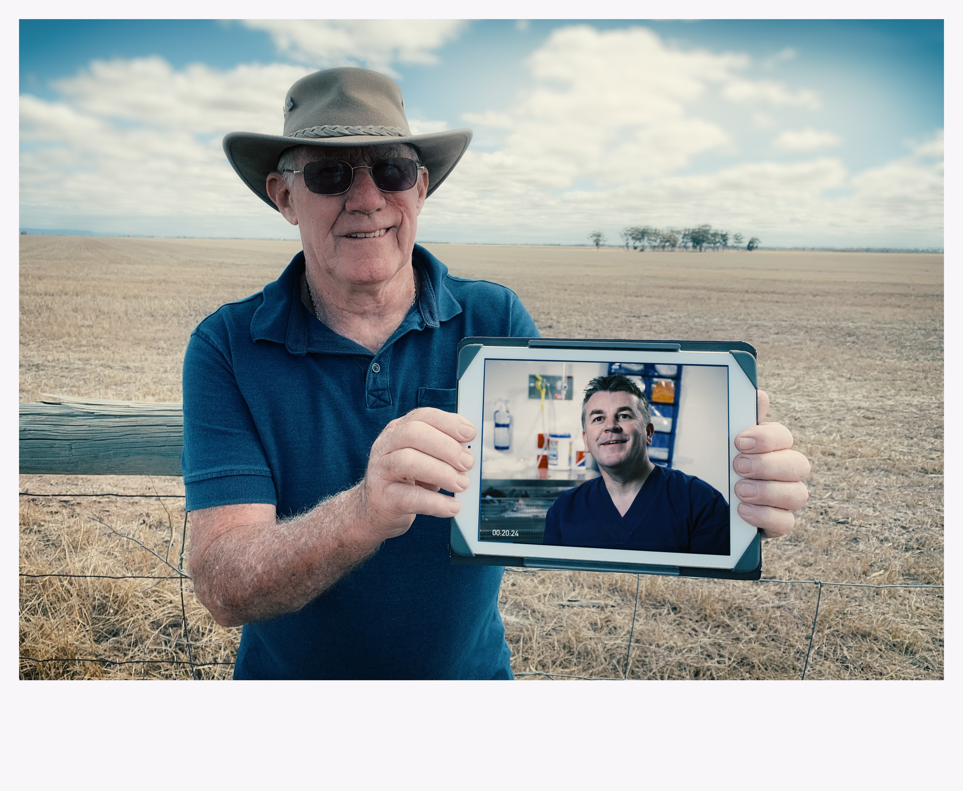

Acknowledgements: This model of care was developed by the Wimmera Southern Mallee Health Alliance to improve access and reduce travel for patients. The Department of Health and Human Services Victoria provided funding to support this work through the Victorian Telehealth Specialist Clinics funding in 2018.

CONTENTS

Contents ………………………………………………………………………………………………………………………………………… 2
Introduction ……………………………………………………………………………………………………………………………………. 3
Technology………………………………………………………………………………………………………………………………………. 3
Training Clinicians……………………………………………………………………………………………………………………………. 4
What does our model look like?........................................................................................................... 4
Pathways ………………………………………………………………………………………………………………………………………… 5
Patient Resources …………………………………………………………………………………………………………………………… 5
List of Project Resources developed ……………………………………………………………………………………………….. 7
Project contact details ……………………………………………………………………………………………………………………. 8

INTRODUCTION
Telehealth offers incredible potential to transform the healthcare delivery system by overcoming geographical distance, enhancing access to care and building efficiencies.
During 2018, the Wimmera Cancer Telehealthcare Project piloted cancer nurses using telehealth to link patients either at the local health service or at home, to their oncologist. Telehealth was also used to reduce transfers to the regional Emergency Department for treatment side effects.
The Healthdirect Video Call platform was used to connect and staff were trained, processes tested and competency built.
This toolkit sets out the steps and resources developed for the project.
Many more fabulous telehealth resources can be found at the Victorian Telehealth Community of Practice website, please click here

TECHNOLOGY
The technology we are using in the Wimmera is the Healthdirect Video Call platform which is a web based which means you can access telehealth from anywhere where there is internet access.
A Healthdirect Video Call licence was arranged with assistance from the Victorian Department of Health and Human Services.
We then developed a simple to access telehealth Waiting Room/consultation room which is accessed via the Wimmera Health Care Group webpage. www.whcg.org.au/telehealth
You will need to work with your organisation’s IT department to set the waiting room up to be accessed through your webpage.
Instructions and how to manual is available from https://telehealthvictoria.org.au/wp-content/uploads/2017/09/Healthdirect-presentation.pdf
All staff for our project where provided with a new laptop or iPad which had good cameras and microphones.
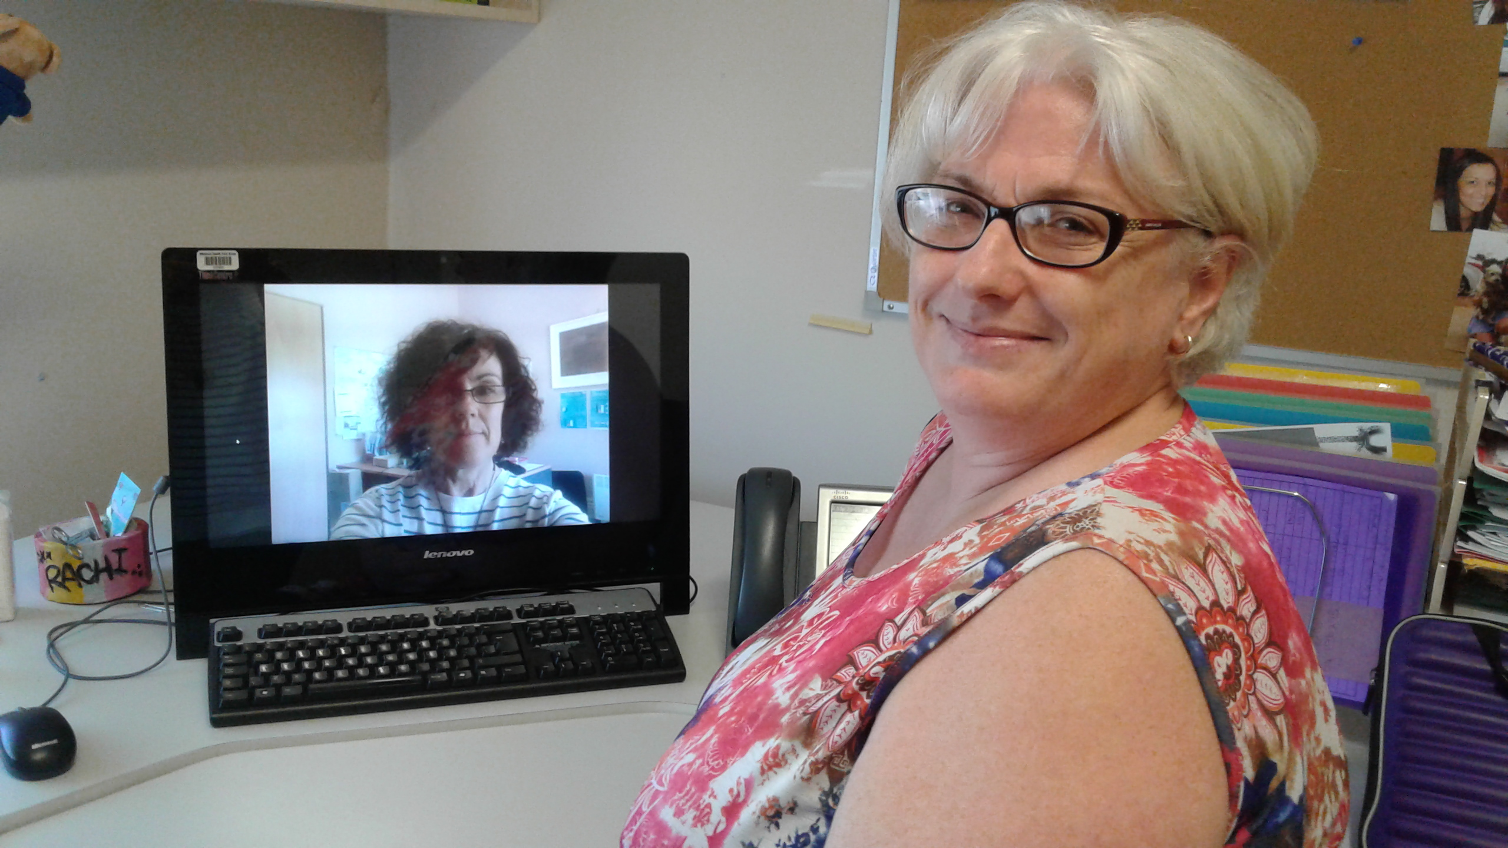

TRAINING CLINICIANS
Healthdirect will organise an orientation for staff on the basics – just contact them directly to arrange.
For our project, the Project Manager (Donna Bridge) spent time learning about the platform and then began testing. She then spent time with our project team training and testing with them… and also trained the Oncologists’ Practice Nurse in using the platform. It is extremely easy to use but our biggest learning is that you MUST use a very recent version of Google Chrome when using PC.

WHAT DOES OUR MODEL LOOK LIKE?
We have set up the Wimmera Cancer Nurse Practitioner as the main point for telehealth consultations. Here are some examples below of how this works.
- Scheduled Cancer Telehealth Clinic with Oncologist, patient attends in Horsham
Wimmera Oncology Nurse Practitioner Based at Wimmera Health Care Group, Horsham
Logs into Healthdirect Video Call. Shortcut setup on WHCG Intranet and also on www.whcg.org.au/telehealth Picks up the video call from the waiting room.
Patient sits with Nurse Practitioner as have been scheduled their next appointment as a telehealth consult and don’t need to travel to the oncologist in Ballarat.

Oncologist
Based at Ballarat Oncology in Ballarat
Sits at their desk and opens their internet browser and goes to the WHCG Waiting room at www.whcg.org.au/telehealth

- Scheduled Cancer Telehealth appointment with Oncologist, patient attends local Wimmera Health Service
Oncologist
Based at Ballarat Oncology in Ballarat
Sits at their desk and opens their internet browser and goes to the WHCG Waiting room at www.whcg.org.au/telehealth
Cancer Resource Nurse
Based at either Rural Northwest Health, West Wimmera Health Service or Edenhope Hospital.
Organises a suitable consult room with computer or iPad and goes to the WHCG Waiting Room at www.whcg.org.au/telehealth)
Patient sits with Cancer Resource Nurse as have been scheduled this next appointment as a telehealth consult and don’t need to travel to either Horsham or Ballarat.

Wimmera Oncology Nurse Practitioner
Based at Wimmera Health Care Group, Horsham
Logs into Healthdirect Video Call. parties. Shortcut setup on WHCG Intranet and also on www.whcg.org.au/telehealth Picks up the both party’s video call from the waiting room and connects everyone.

- Scheduled Cancer Telehealth appointment with Oncologist, patient attends at home with support
Oncologist
Based at Ballarat Oncology in Ballarat
Sits at their desk and opens their internet browser and goes to the WHCG Waiting room at www.whcg.org.au/telehealth
Cancer Resource Nurse
Based at either Rural Northwest Health, West Wimmera Health Service or Edenhope Hospital.
Travels to the patient’s home with computer or iPad and goes to the WHCG Waiting Room at www.whcg.org.au/telehealth)
Patient at home with Cancer Resource Nurse doesn’t need to travel to either Horsham or Ballarat.

Wimmera Oncology Nurse Practitioner
Based at Wimmera Health Care Group, Horsham
Logs into Healthdirect Video Call (shortcut setup on WHCG Intranet and also on www.whcg.org.au/telehealth). Picks up the video call from the waiting room.

- Patient presents at any Wimmera Urgent Care Centre with Cancer treatment side effects or is an acute patient
Acute & Urgent Care Nursing staff
Based at either Rural Northwest Health, West Wimmera Health Service or Edenhope Hospital.
Follows the Acute/Urgent Care Cancer Telehealth pathway. Using a computer or iPad goes to the WHCG Waiting Room at www.whcg.org.au/telehealth)
Patient at their local health service and doesn’t need to travel to the Emergency Department in Horsham or it is agreed that a transfer is necessary.

Wimmera Oncology Nurse Practitioner
Based at Wimmera Health Care Group, Horsham
Logs into Healthdirect Video Call (shortcut setup on WHCG Intranet and also on www.whcg.org.au/telehealth). Picks up the video call from the waiting room.
If required, Oncologist can also be invited into the meeting room.

I

PATHWAYS
We developed two pathways so that accessing telehealth was clear and simple. These were tested by staff and their feedback incorporated into the final documents. Here they are for you:
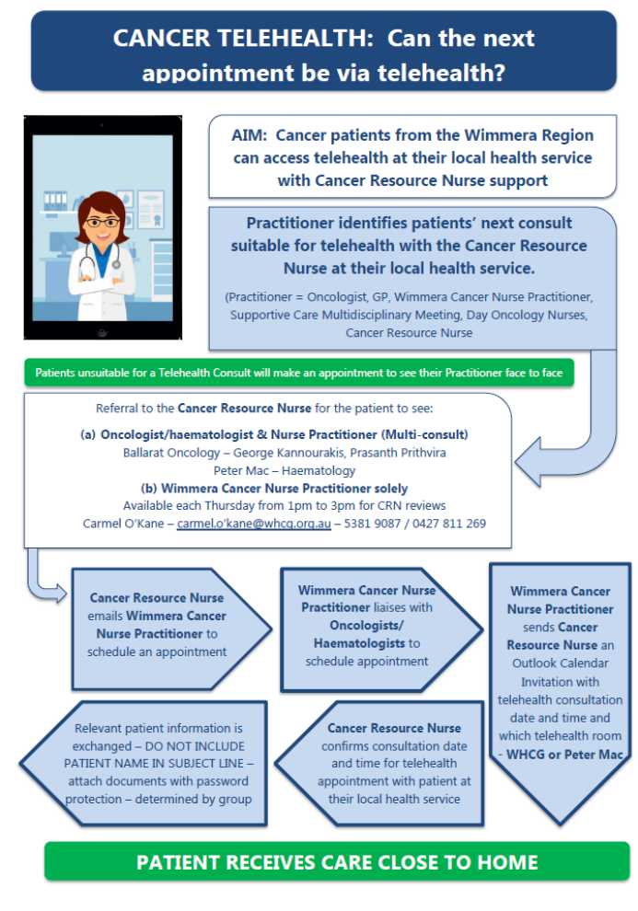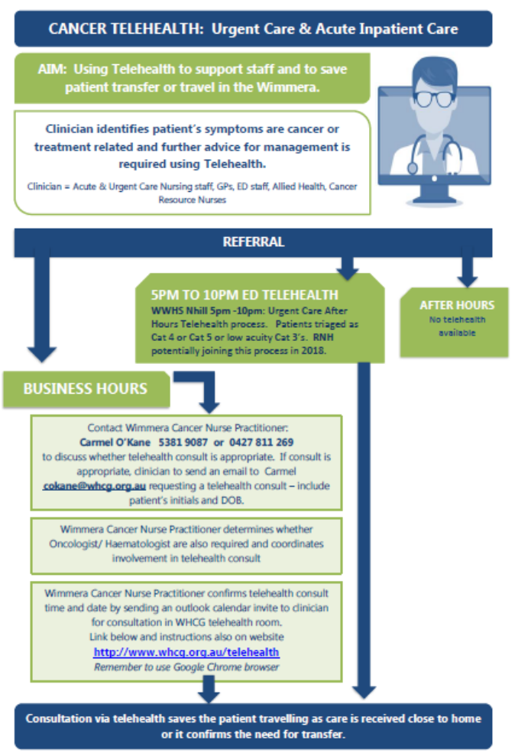

PATIENT RESOURCES
We also developed patient resources to encourage Telehealth which included short animations for waiting rooms (see https://www.powtoon.com/c/bMxHEJuJPKV/1/m ) posters and business cards. Our Consumer Advisor who sits on our Working Group suggested these business cards as something that people will keep and put into their wallets.
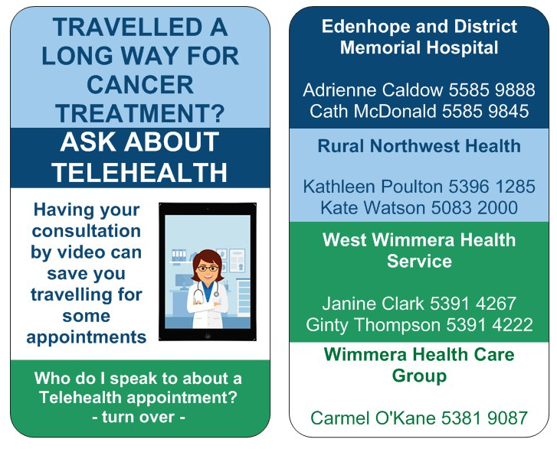
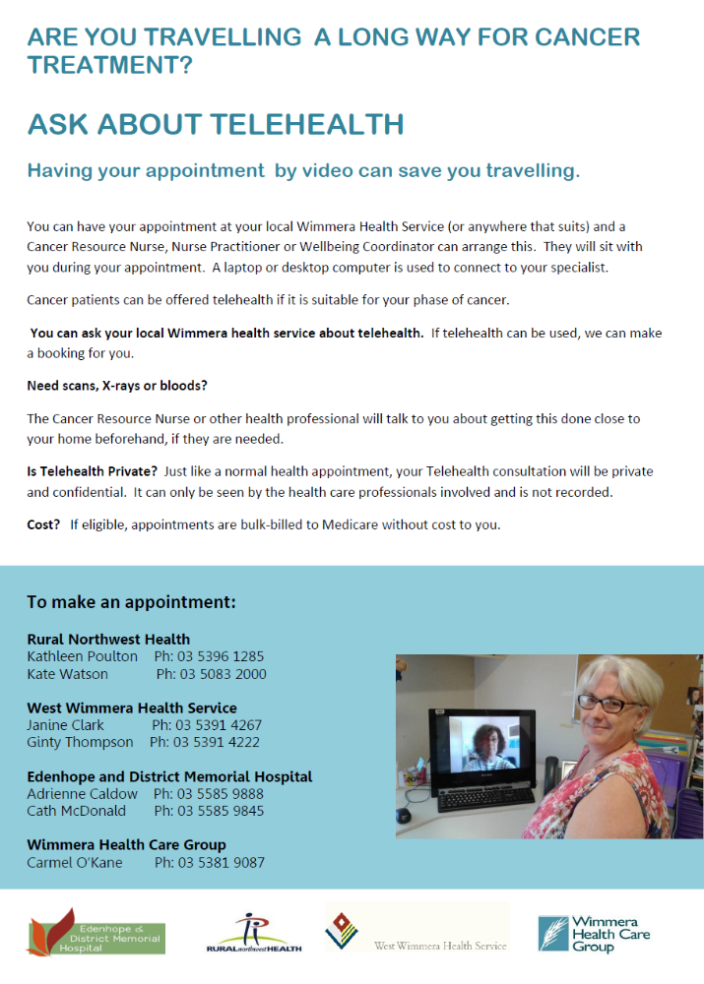

Here is our full list of Resources developed for the project. We are happy to share any of these.
Wimmera Cancer Telehealthcare Project resources List
Description | Target audience | File | Feedback/approval PROVIDED
Ask about Telehealth A4/A3 poster | Patients, GPs, community members, health professionals | 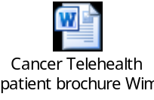 | Approved.
Travelled a long way – Patient business card | Patients |  | Approved.
Instructions: Telehealth video consult with Wimmera Health Care Group | Staff at health services, GPs, Specialists. |  | Approved.
Pathway – Can the next appointment be via telehealth with the Cancer Resource Nurse at local health service. | Health professionals | 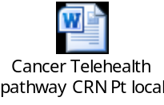 | Tested and approved.
Pathway – Cancer Telehealth Urgent Care & Acute Inpatient Care | Nursing staff – Urgent care, Acute & ED, GPs, |  | Tested and approved.
Telehealth Patient Evaluation  -this automatically pops up at the end of the telehealth consult or can be completed paper version.  One Question Version | Patients  DHHS as part of evaluation |   
Telehealth Staff Evaluation | Staff | 
Wimmera Postcodes to identify patients for telehealth | Health Services, specialists, |  | Working Group – no further action required. Resource can be given to any health service so that they can identify Wimmera patients for telehealth consultations.
Wimmera Cancer Capabilities Info Sheet | Other health services and regions | 

For further information on this project please contact:
Donna Bridge
Wimmera Southern Mallee Health Alliance Project Manager
Wimmera Primary Care Partnership
Ph: 5362 1221 mob: 0490 800 911
E: donna.bridge@wimmerapcp.org.au

